**How to access Linux from Windows**

**Prerequisites:**

* Linux box must be running **SSH server**
* Windows box must have **SSH client** ( putty for example )
* There must be working network connection between those machines

**Lab Info:**

IP: **localhost** / 127.0.0.1

Port: **2222**

User: **student**

**Connection procedure:**

1. Download putty <http://the.earth.li/~sgtatham/putty/latest/x86/putty.exe>
2. Open putty

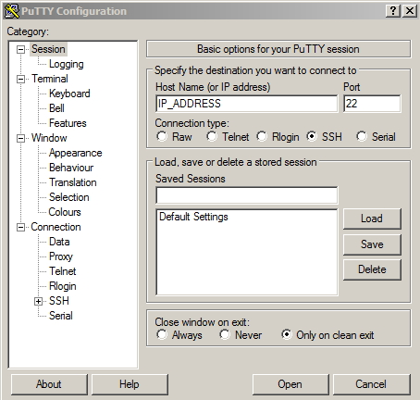

1. *** Put IP address of Linux server in “*Host Name ( or IP address)*” box
2. Click *“Open”*
3. First time when you connect you must accept RSA key click “Yes”

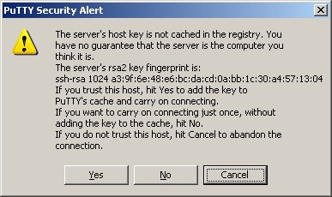

1. Enter password for user (in some cases user must be inserted by you)

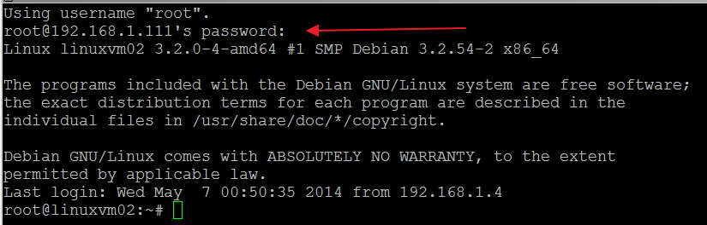

*\*\*\* In Step 3 if you want to include username syntaxis is “ USER@IP_ADDRESS_OR_HOST”*

**How to access Linux from Linux or Mac**

1. Open your Terminal and type

*ssh –l USERNAME IP_ADDRESS –p PORT*

*or*

*ssh USERNAME@IP_ADDRESS -p PORT*

1. Enter password for user - if you don’t specify a user it must be inserted by you

